**Experiment 2.4**

**Student Name: Sahul Kumar Parida UID: 20BCS4919**

**Branch: CSE Section/Group: WM 904/B**

**Semester: 5th Date of Performance: 02/11/22**

**Subject Name: Machine Learning Lab Subject Code: CSP-317**

**1. Aim/Overview of the practical:**

To implement Decision Tree and compare the performance with Random Forest on any data set.

# 2. Task to be done:

# Decision Tree

i) First, we’ll import the libraries required to build a decision tree in Python.

ii) Separate the independent and dependent variables using the slicing method.

iii) Split the data into training and testing sets.

iv) Train the model using the decision tree classifier.

v) Predict the test data set values using the model above.

vi)  Calculate the accuracy of the model using the accuracy score function.

**Random Forest**

vii) Import the required libraries.

viii) Fit Random forest regressor to the dataset.

ix) Predicting a new result.

# 3. Apparatus/Simulator used:

* Jupyter Notebook/Google Collab
* A decision tree is a tree-based supervised learning method used to predict the output of a target variable. Supervised learning uses labeled data (data with known output variables) to make predictions with the help of regression and classification algorithms. Supervised learning algorithms act as a supervisor for training a model with a defined output variable. It learns from simple decision rules using the various data features. Decision trees in Python can be used to solve both classification and regression problems—they are frequently used in determining odds.

**4. Code and Output:**

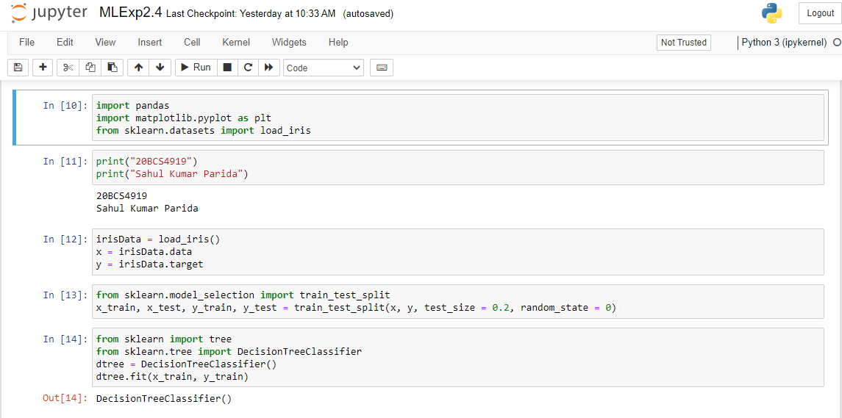

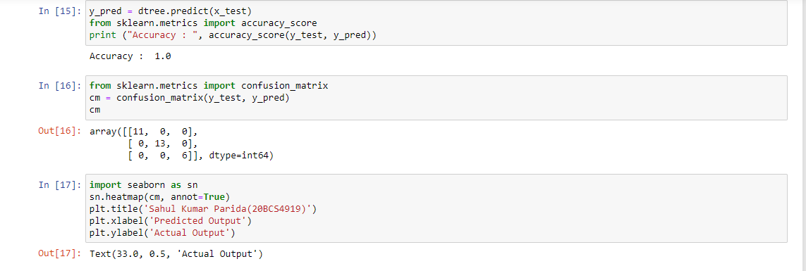

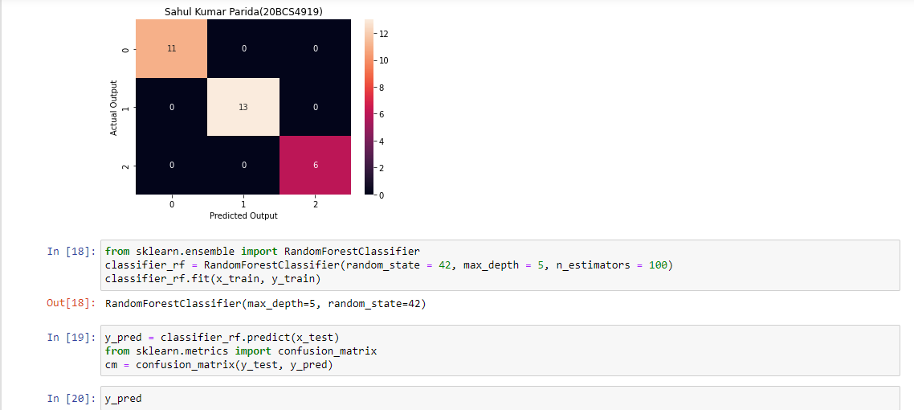

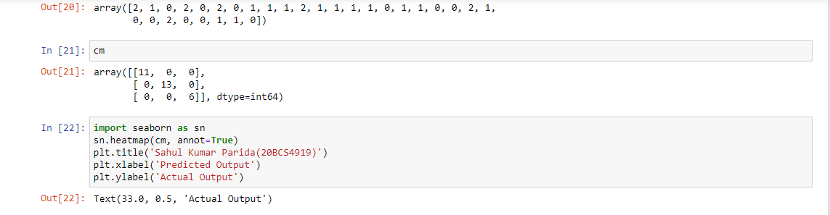

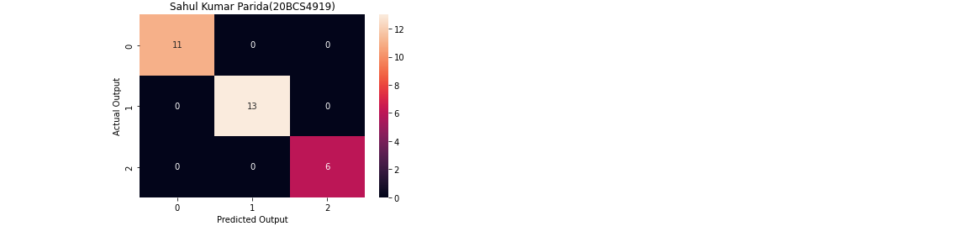

**Learning outcomes (What I have learnt):**

1. Learning about different library/packages of python.
2. Learning about the different methods, that are needed to analyze the given dataset.
3. Learning about different Machine Learning Functions.
4. We learn to split data into training and testing datasets.
5. Implementation of decision tree and random forest on any dataset.